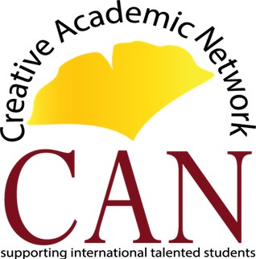

The CAN Scholastic Foundation & GATE Global Alliance for Talent Education

2018

Summer STEAM Teaching and Exploration in China

Program Date: July 1st – July 31st (dates may change slightly due to ticket and travel availability).
Content/STEAM:
This opportunity is designed for talented Chinese students with strong English skills and the desire to be challenged by an interesting and rigorous project-based curriculum. Course content is balanced between educators’ background and students’ needs. All participants in the program are exceptional learners and educators. Here is your chance to contribute to the transformation in the lives of both students and teachers by using American methodological training techniques in a cross-cultural environment. Your input will inspire and invigorate your learners through a cross-disciplinary course design based on the principles of STEAM.
Professional Development: Is your goal to improve teaching strategies in China utilizing innovative pedagogical techniques through continuing education?
If so, this option is designed for you. Chinese English teachers are eager to learn how to develop critical thinking skills and encourage creativity and innovation in the classroom. By studying with native English speaking educators, the Chinese English teachers learn inter-cultural methodologies and best practices. In some cases, you may be the first and only native English speaker to teach ESOL methodologies for your students. Your Chinese teachers will benefit from your contribution by impacting tens of thousands of students and making a long-term difference in their education! Their linguistic and cultural understanding of the English language will improve teaching practices for many generations of Chinese students in the years to come.
Join us and make a difference!
