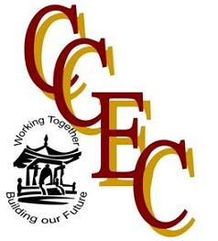

The Chinese Culture and Education Center (CCEC) & CAN Scholastic Foundation

2018

Summer English Teaching and Exploration in China

Program Date: July 1st – July 31st (dates may change slightly due to ticket and travel availability).
Student English Camp: Are you interested in cultural exchange and intrigued by the history and social habits of the Chinese?
This initiative is designed to expose you to Chinese language, history and culture through teaching and interacting with gifted students from Elementary, Middle or High School. Your students will aspire to learn everything about American life and culture. It is essential that Chinese Students improve their technical English competencies through creative teaching approaches that focus on interactive oral communication. Your participation in the program will broaden the perspectives of many learners and also benefit them and you immeasurably. You could be that teacher that inspires the next generation of English learners in China.
Professional Development: Is your goal to improve teaching strategies in China utilizing innovative pedagogical techniques through continuing education and share with your Chinese peers?
If so, this option is designed for you. Chinese English teachers are eager to learn how to develop critical thinking skills and encourage creativity and innovation in the classroom. By studying with native English speaking educators, the Chinese English teachers learn inter-cultural methodologies and best practices. In some cases, you may be the first and only native English speaker to teach ESOL methodologies for your students. Your Chinese teachers will benefit from your contribution by impacting tens of thousands of students and making a long-term difference in their education! Their linguistic and cultural understanding of the English language will improve teaching practices for many generations of Chinese students in the years to come.
What are you waiting for?

Join us and make a difference!


